

Europass  Curriculum Vitae |  | 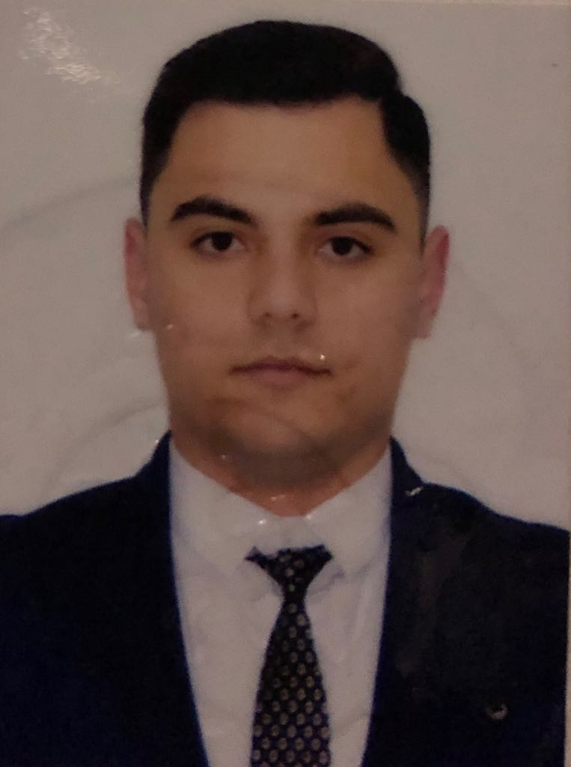
Personal information
First name(s) / Surname(s) |  | Alexandru Ionut JUDELE
Address(es) |  | 22B, Tiberiu Brediceanu, 907015, Constanta, ROMANIA
Telephone(s) |  | (0341 459 290) |  |  |  |  | Mobile: |  |  |  | 0723517767
Fax(es) |  | -
E-mail |  | alex.1510@yahoo.com
Nationality |  | romanian
Date of birth |  | 15-10-1995
Gender |  | male
Desired employment / Occupational field |  | Specialized professionally as a Assistant Manager Junior and Waiter in public food unit (a-la-carte), sales assistant in multinational company
Work experience
Dates |  | 2017- 2018 - Pescaria lui Matei S.R.L - Assistant Manager Junior and Waiter a-la-carte  2017 - ADIDAS co. - sales assistant  2016-2017 - Pescaria lui Matei S.R.L - Assistant Manager Junior  2015-2016 - SUNSET Pizza - sales assistant  2014 - EGO Club, MAMAIA RESORT- Waiter a-la-carte
Name and address of employer |  | EGO Club, MAMAIA RESORT  SUNSET Pizza, Agigea, Constanta  Pescaria lui Matei S.R.L, Agigea, Constanta  ADIDAS co., Romania
Type of business or sector |  | Dining facilities  Retail sales
Education and training
Dates |  | 2014-2018 Maritime University, Constanta, Romania  2016 Basing training, CERONAV Romanian Maritime Training Centre ( Personal survival techniques; Personal safety and social responsibilities on board ships; Basic fire-fighting; Elementary first AID.- the training program has approved by the Romanian Naval Authority.  2016 Security awareness training & security training for seafarers with designated security duties, CERONAV Romanian Maritime Training Centre- the training program has approved by the Romanian Naval Authority.  2011-2014 Economic College Carol, Constanta, Romania
Title of qualification awarded |  | - technician in trade activities, service profile.
Personal skills and competences
Mother tongue(s) |  | Romanian language
Other language(s)
 |  |  | Understanding |  |  |  |  | Speaking |  |  |  |  | Writing
 |  |  | Listening |  | Reading |  |  | Spoken interaction |  | Spoken production
Engleza |  |  |  | A2 |  | A2 |  |  | B2 |  |  | B2 |  | A2
Language
Social skills and competences |  | Teamwork: For 2 years I have arbitrated in the 4th junior football league
Computer skills and competences |  | The base knowledge of PC: Word, Excel, Outlook, PowerPoint; Operating Windows systems.
Hobby |  | Sports, travelling
Driving licence |  | driving licence for “B” categorie of vehicle.
Additional information |  | Seaman’s book, Certificate of Proficiency, Passport

